Project Contract

1.Student Name: Ruya Kumru-Holroyd

2.P-number: P2512547

3.Programme: BSc Computer Games Programming

4.Email address: p2512547@my365.dmu.ac.uk

5.Project Title: Creating a control mapping program for game accessibility.

6.Project Proposer: DMU Internal (R. Kumru-Holroyd & J. Shell – CTEC3451 Development Project)

7.Supervisor: Dr Jethro Shell

8.Introduction (max. 100 words): There are millions of video games out there in the world, but how many are truly accessible and have the right representation? The answer is less than you would hope, which is why I am creating a project that will show it is possible to do and can be used and adapted for future use.

9.Project Background (max. 300 words): The project background comes from my own interests and aims, I have always enjoyed games and once found a charity that specialises in making game hardware for those with disabilities, I found it special and intriguing and always believed that I would like to do that myself one day but more with the software side of things, which is where my project comes in as a starting point. In researching this topic, I found that out of the millions of games out there, only a fraction of them have any accessibility settings or representation of disability of any kind in them, this made me upset as I know how much games have done to help me escape from my own mental health in the past and that it was a shame that those with their own disabilities are unable to play the games they could really enjoy, which is why I wanted to create this project as a showcase that it is possible and that everyone should be able to play games as well as represent those people within games to help them feel seen.

10.Aims (max. 100 words):The aim of this project is to create a program that will map the specific control settings and its key bindings, off a prototype game and transfer them onto a different prototype game.

11.Objectives (max. 200 words): Objectives that will result in a deliverable are at least two prototype games that will be used to test and perform the processing of mapping inputs and outputs, which in itself is an objective. These two prototype games will include disability representation and be accessible in their own ways with the ability to key bind and set controls and it is those things that will be mapped and outputted from one prototype game to the other. The software that will be created will be suitably well constructed and work as intended. Furthermore, an objective is User Testing, gaining primary data from a group of individuals in testing the two protype games and the process of mapping inputs and outputs of their specific control settings. Finally, a report that will include sections such as a literature review, acknowledgements, methodology, testing approach and references.

12.Deliverables (max. 100 words): The deliverables are going to be a software that has two game prototypes and a method that maps input of controller and key-binding settings and any other accessibility setting from one prototype game and outputs it to the second one.

13.Resources and Constraints (max. 100 words): Software that will be used is Unity3D and Visual Studio 2019, I will also have a body of individuals for testing, these individuals will be found at a later date in the project with help of the supervisor.

14.Sources of Information (max. 100 words): Sources I intend to use are books such as; Game Usability by Katherine Isbister and Noah Schaffer and Accessibility in Games: Including People with Disabilities by Silvio Carrera. Also, a podcast on Amazon music; accessibility in gaming by chelby farley. I also intend to use articles found using Google Scholar with key search names such as video game accessibility, disabilities, and mental health. I will also be researching code online to help create the project. I will also try and collect primary data through people for testing of the project.

15. Risk Analysis (max. 100 words): Software could be a danger to the project, this could be by losing the code or files, to combat this, regularly save all files and back it up using programs such as GitHub. Hardware could also be an issue if it breaks, again have it widely backed up and use another computer or online DMU virtual labs to access and complete project. A final risk to the project is the User testing and getting a hold of the right people for testing, having several different avenues and back ups of people will help combat this risk.

16.Schedule of Activities (max. 300 words): I will have a Gantt chart that will be used for project management, have a list of different parts of the project, assign time slots for each part and plan ahead, as well as have an expected time to complete these tasks and then note down the real time it is taking for each task to see how I long it is really taking and to keep on track. My project plan is starting with the Literature review, and then moving onto doing research and whilst doing research starting to slowly plan and develop the two game prototypes but mainly focusing on research as to not get carried away in the prototype development. Once research is complete, fully finish developing the two prototype games and begin development on the mapping methodology, breaking down the tasks for each part of the development to ensure smooth project management. Once the code, games and program are complete I will move on to User Testing finding the right group of individuals for testing and gaining data from them, using this data to complete the final report which I will be working on throughout the whole time of the project, starting with the acknowledgements and introduction after that moving onto contents such as literature review, functional requirements, system documentation, testing, implementation report and finally references and appendices.

Gantt chart:

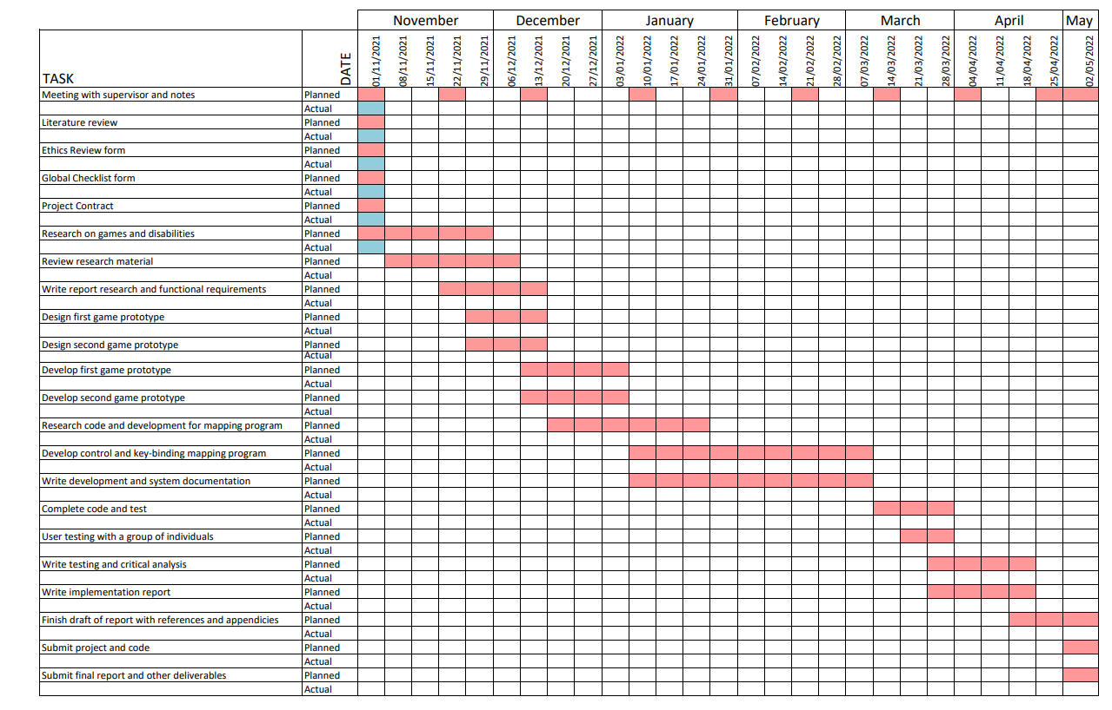

17.Student Signature: Ruya Kumru-Holroyd

18.Supervisor Signature:

19.Date: 4/11/21